 P
Index

SI. | Problem Statement
1 | Write a program on signal operation - addition, shifting, folding, multiplication.
2 | Visualization of Discreate time signals: Impulse ,steps and Ramps signals
3 | Explain and implementation of Convolution operation of sequences
4 | Explain and implementation of Correlation operation of sequences.
5 | Write a program on PPG signal - filtering, feature extraction, peak detection
6 | Explain and implementation of fourier series decomposition
7 | Write a program on DFT (Discrete Fourier Transform) and IDFT.
8 | Explain and implementation of fourier transform

#Problem 1:
import numpy as np
import matplotlib.pyplot as plt
def signal_addition(x1, x2):
return x1 + x2

def signal_multiplication(x1, x2):
return x1 * x2

def signal_scaling(x, alpha):
return alpha * x

def signal_shifting(n, shift):
return n + shift

def signal_folding(x):
return np.flip(x)

n = np.array([-2, -1, 0, 1, 2])
x1 = np.array([1, 2, 3, 4, 5])
x2 = np.array([5, 4, 3, 2, 1])

added_signal = signal_addition(x1, x2)
multiplied_signal = signal_multiplication(x1, x2)
scaled_signal = signal_scaling(x1, 2)
shifted_signal1 = signal_shifting(n, -2)
shifted_signal2 = signal_shifting(n, 2)
folded_signal = signal_folding(x1)

plt.figure(figsize=(12, 10))

plt.subplot(4, 2, 1)
plt.stem(n, x1)
plt.xlabel("Time")
plt.ylabel("Amplitude")
plt.title("Original Signal x1")
plt.grid()

plt.subplot(4, 2, 2)
plt.stem(n, x2)
plt.xlabel("Time ")
plt.ylabel("Amplitude")
plt.title("Original Signal x2")
plt.grid()

plt.subplot(4, 2, 3)
plt.stem(n, added_signal)
plt.xlabel("Time")
plt.ylabel("Amplitude")
plt.title("Signal Addition")
plt.grid()

plt.subplot(4, 2, 4)
plt.stem(n, multiplied_signal)
plt.xlabel("Time")
plt.ylabel("Amplitude")
plt.title("Signal Multiplication")
plt.grid()

plt.subplot(4, 2, 5)
plt.stem(n, scaled_signal)
plt.xlabel("Time")
plt.ylabel("Amplitude")
plt.title("Scaled Signal (x1 * 2)")
plt.grid()

plt.subplot(4, 2, 6)
plt.stem(shifted_signal1, x1)
plt.xlabel("Time")
plt.ylabel("Amplitude")
plt.title("Shifted Signal (Shift = -2)")
plt.grid()

plt.subplot(4, 2, 7)
plt.stem(shifted_signal2, x1)
plt.xlabel("Time")
plt.ylabel("Amplitude")
plt.title("Shifted Signal (Shift = +2)")
plt.grid()

plt.subplot(4, 2, 8)
plt.stem(n, folded_signal)
plt.xlabel("Time")
plt.ylabel("Amplitude")
plt.title("Folded Signal (x1)")
plt.grid()

plt.tight_layout()
plt.show()
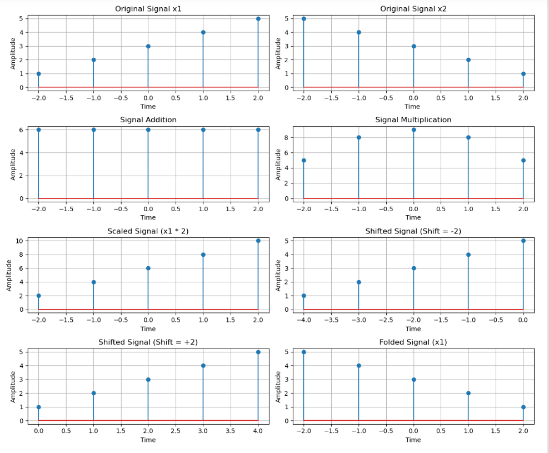
#Problem 2:

import numpy as np
import matplotlib.pyplot as plt

n = np.arange(-20, 20) # Discrete time index

impulse = np.where(n == 0, 1, 0)

step = np.where(n >= 0, 1, 0)

ramp = np.where(n >= 0, n, 0)

plt.figure(figsize=(12, 6))

plt.subplot(1, 3, 1)
plt.stem(n, impulse, use_line_collection=True)
plt.title("Impulse Signal")
plt.xlabel("n")
plt.ylabel("Amplitude")
plt.grid()

plt.subplot(1, 3, 2)
plt.stem(n, step, use_line_collection=True)
plt.title("Step Signal")
plt.xlabel("n")
plt.ylabel("Amplitude")
plt.grid()

plt.subplot(1, 3, 3)
plt.stem(n, ramp, use_line_collection=True)
plt.title("Ramp Signal")
plt.xlabel("n")
plt.ylabel("Amplitude")
plt.grid()

plt.tight_layout()
plt.show()

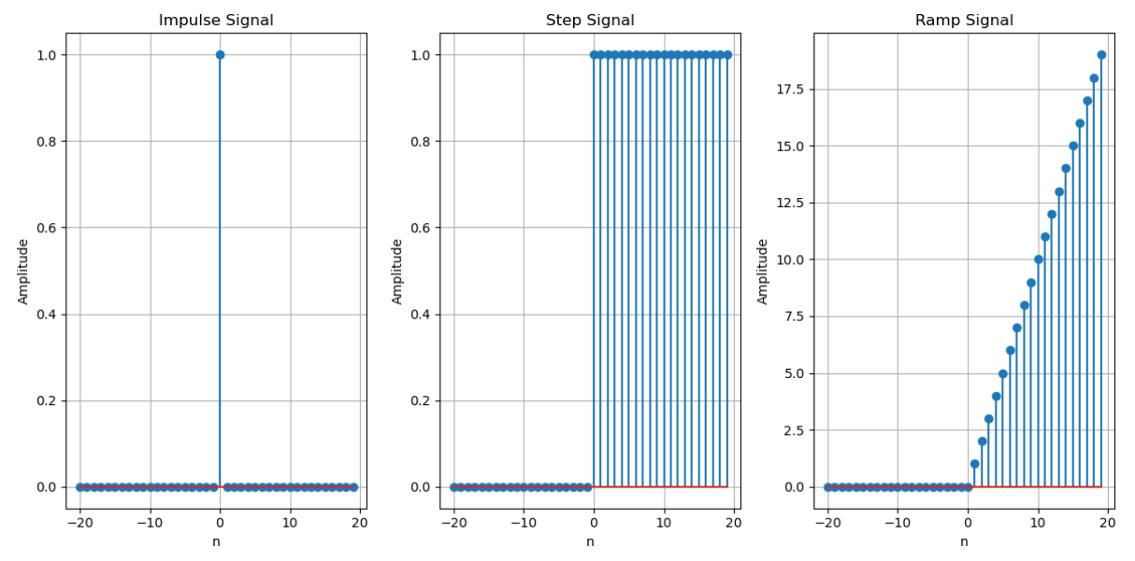

#Problem 3:
import numpy as np
import matplotlib.pyplot as plt
from scipy.signal import convolve
def compute_convolution(signal1, signal2):
conv_result = convolve(signal1, signal2, mode='full', method='auto')
return conv_result
fs = 1000
t = np.linspace(0,1,fs, endpoint=False)
freq = 5
sin_signal=np.sin(2 * np.pi * freq * t)
conv_auto = compute_convolution(sin_signal, sin_signal)
signal1 = sin_signal
signal2 = np.roll(signal1, 100)
conv_shifted = compute_convolution(signal1, signal2)
noise = np.random.normal(0, 0.5, fs)
noisy_signal = signal1+ noise
conv_noisy = compute_convolution(signal1, noisy_signal)

plt.figure(figsize=(12,6))

plt.subplot(3, 1, 1)
plt.plot(conv_auto)
plt.title("Autoconvolution of a Sinusoidal Signal")
plt.xlabel("Samples")
plt.ylabel("Convolution Output")
plt.grid()

plt.subplot(3, 1, 2)
plt.plot(conv_shifted)
plt.title("Convolution between Signal and Shifted Version")
plt.xlabel("Samples")
plt.ylabel("Convolution Output")
plt.grid()

plt.subplot(3, 1, 3)
plt.plot(conv_noisy)
plt.title("Convolution with Noisy Signal")
plt.xlabel("Samples")
plt.ylabel("Convolution Output")
plt.grid()

plt.tight_layout()
plt.show()

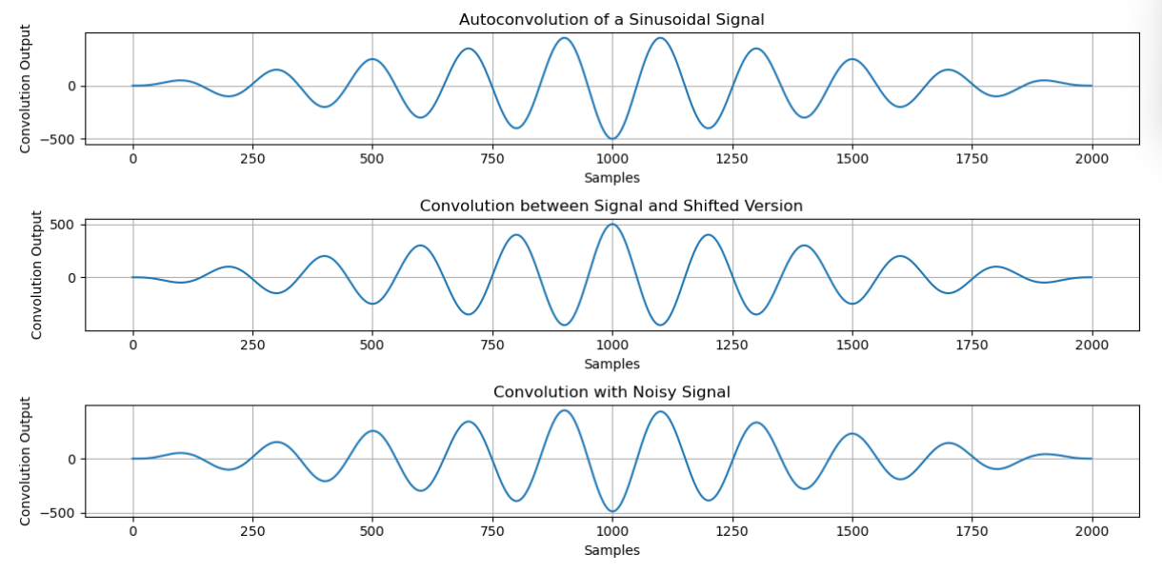

#Problem 4:

import numpy as np
import matplotlib.pyplot as plt
from scipy.signal import correlate, correlation_lags
def compute_autocorrelation(signal):
auto_corr = correlate(signal, signal, mode='full', method='auto')
lags = correlation_lags(len(signal), len(signal), mode='full')
return auto_corr, lags
def compute_cross_correlation(signal1, signal2):
cross_corr = correlate(signal1, signal2, mode='full', method='auto')
lags = correlation_lags(len(signal1), len(signal2), mode='full')
return cross_corr, lags

fs = 1000
t = np.linspace(0, 1, fs, endpoint=False)
freq = 5

sin_signal = np.sin(2 * np.pi * freq * t)

auto_corr, lags_auto = compute_autocorrelation(sin_signal)
signal1 = sin_signal
signal2 = np.roll(signal1, 100)
cross_corr, lags_cross = compute_cross_correlation(signal1, signal2)
noise = np.random.normal(0, 0.5, fs)
noisy_signal = signal1 + noise
cross_corr_noise, lags_noise = compute_cross_correlation(signal1, noisy_signal)

plt.figure(figsize=(12, 12))

plt.subplot(3, 1, 1)
plt.plot(lags_auto, auto_corr)
plt.title("Autocorrelation of a Sinusoidal Signal")
plt.xlabel("Lag")
plt.ylabel("Autocorrelation")
plt.grid()

plt.subplot(3, 1, 2)
plt.plot(lags_cross, cross_corr)
plt.title("Cross-Correlation between Two Signals")
plt.xlabel("Lag")
plt.ylabel("Cross-Correlation")
plt.grid()

plt.subplot(3, 1, 3)
plt.plot(lags_noise, cross_corr_noise)
plt.title("Cross-Correlation with Noisy Signal")
plt.xlabel("Lag")
plt.ylabel("Cross-Correlation")
plt.grid()

plt.tight_layout()
plt.show()

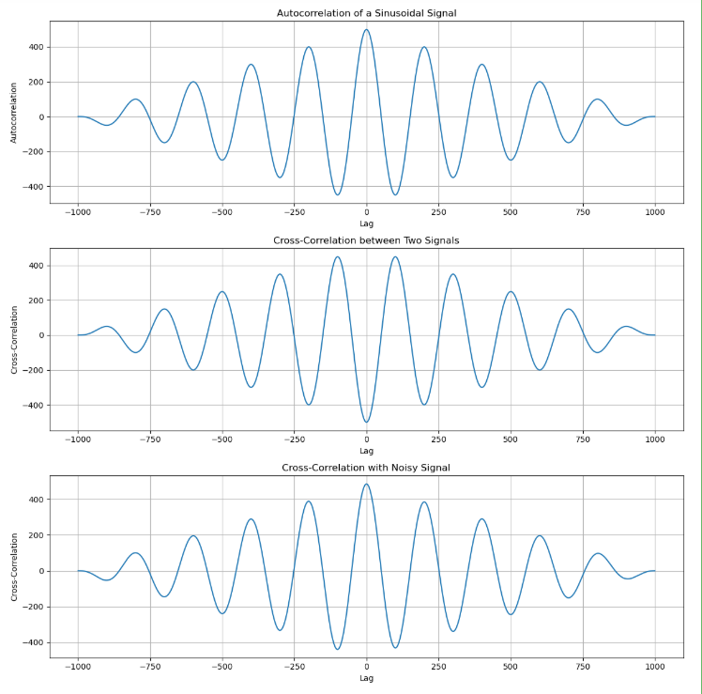

#Problem 5:

import numpy as np
import matplotlib.pyplot as plt
from scipy.signal import find_peaks

fs = 100
t = np.linspace(0, 10, 10 * fs)
# Create a synthetic PPG-like waveform using a sum of sinusoids and added noise
ppg = 0.6 * np.sin(2 * np.pi * 1.2 * t) + 0.4 * np.sin(2 * np.pi * 2.4 * t) + 0.05 * np.random.randn(len(t))
ppg = ppg - np.min(ppg) # baseline shift

# Detect systolic peaks using a prominence filter
min_prominence = 0.2 # adjust this value based on your signal
peaks, peak_props = find_peaks(ppg, prominence=min_prominence, distance=fs/2)
systolic_peaks = peaks # indices of systolic peaks
diastolic_points = []
for i in range(len(systolic_peaks)-1):
start = systolic_peaks[i]
end = systolic_peaks[i+1]
segment = ppg[start:end]
if len(segment) > 0:
local_min = np.argmin(segment) + start
diastolic_points.append(local_min)
diastolic_points = np.array(diastolic_points)
if len(systolic_peaks) > 1:
ibi = np.diff(systolic_peaks) / fs
heart_rate = 60 / np.mean(ibi)
else:
heart_rate = np.nan
print("Detected systolic peaks (sample indices):", systolic_peaks)
print("Detected diastolic points (sample indices):", diastolic_points)
print("Estimated Heart Rate (BPM):", heart_rate)
# Plot the results
plt.figure(figsize=(12, 4))
plt.plot(t, ppg, label="PPG Signal")
plt.plot(t[systolic_peaks], ppg[systolic_peaks], "ro", label="Systolic Peaks")
plt.plot(t[diastolic_points], ppg[diastolic_points], "go", label="Diastolic Points")
plt.xlabel("Time (s)")
plt.ylabel("Amplitude")
plt.legend()
plt.title("PPG Signal Feature Extraction")
plt.show()
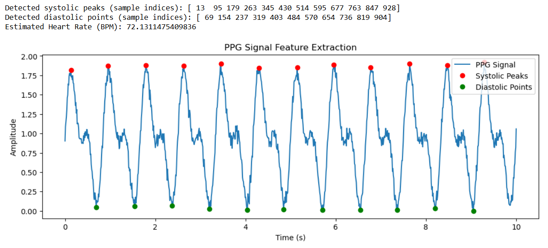

#Problem 6:

import numpy as np
import matplotlib.pyplot as plt
from scipy.integrate import quad

# Define the periodic function (square wave in this case)
def f(x):
return 1 if x < np.pi else -1

# Fourier coefficients
T = 2 * np.pi # Period
omega = 2 * np.pi / T

# Compute a0
a0 = (1 / T) * quad(lambda x: f(x), 0, T)[0]

def an(n):
return (2 / T) * quad(lambda x: f(x) * np.cos(n * omega * x), 0, T)[0]

def bn(n):
return (2 / T) * quad(lambda x: f(x) * np.sin(n * omega * x), 0, T)[0]

# Reconstruct function using Fourier series
def fourier_series(x, terms=10):
sum_terms = a0 / 2 # DC component
for n in range(1, terms + 1):
sum_terms += an(n) * np.cos(n * omega * x) + bn(n) * np.sin(n * omega * x)

# Plot original function and Fourier approximation
x_vals = np.linspace(0, 2 * np.pi, 400)
f_vals = np.array([f(x) for x in x_vals])
fourier_vals = np.array([fourier_series(x, terms=10) for x in x_vals])

plt.figure(figsize=(8, 4))
plt.plot(x_vals, f_vals, label='Original Function', linestyle='dashed')
plt.plot(x_vals, fourier_vals, label='Fourier Approximation (10 terms)')
plt.legend()
plt.xlabel('x')
plt.ylabel('f(x)')
plt.title('Fourier Series Approximation of a Square Wave')
plt.grid()
plt.show()

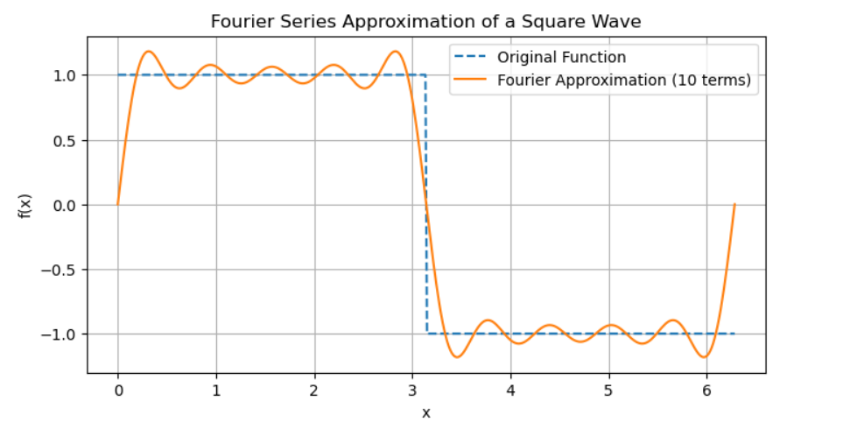

#Problem 7:

import numpy as np
import matplotlib.pyplot as plt

def DFT(x):
"""
Compute the Discrete Fourier Transform (DFT) of a 1D signal.
"""
N = len(x)
X = np.zeros(N, dtype=complex) # Output array (complex numbers)
for k in range(N): # Loop over frequency bins
for n in range(N): # Loop over time samples
X[k] += x[n] * np.exp(-2j * np.pi * k * n / N)
return X
# Create a sample signal (two sine waves)
Fs = 1000 # Sampling rate
T = 1 / Fs # Sampling interval
t = np.linspace(0, 1, Fs, endpoint=False) # 1 second duration
# Signal: Combination of 50 Hz and 120 Hz sine waves
f1, f2 = 50, 120
signal = np.sin(2 * np.pi * f1 * t) + 0.5 * np.sin(2 * np.pi * f2 * t)
# Compute DFT
dft_output = DFT(signal)
# Compute frequency bins
freqs = np.fft.fftfreq(len(dft_output), T)
# Plot magnitude spectrum (single-sided)
plt.figure(figsize=(10, 5))
plt.plot(freqs[:Fs//2], np.abs(dft_output[:Fs//2])) # Single-sided spectrum
plt.title("DFT Frequency Spectrum")
plt.xlabel("Frequency (Hz)")
plt.ylabel("Magnitude")
plt.grid()
plt.show()

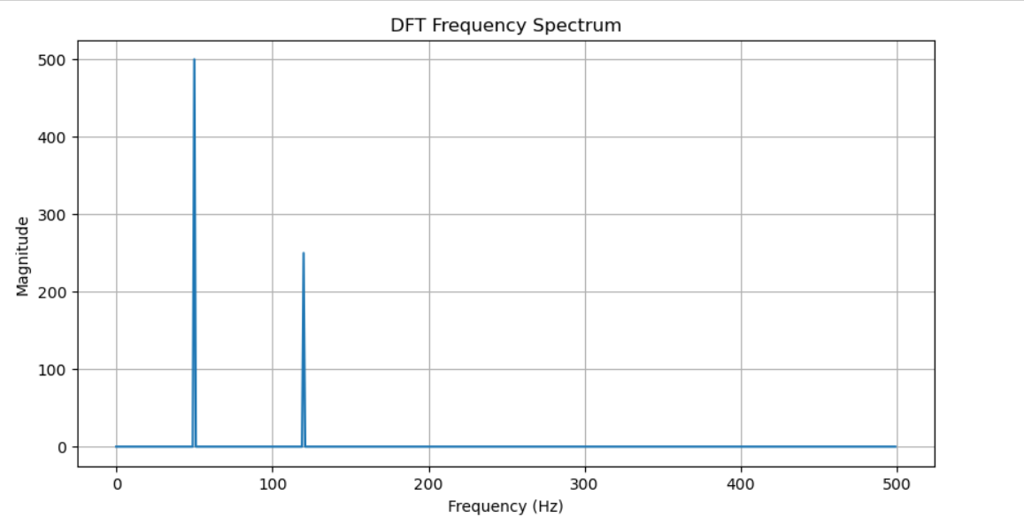
#Problem 8:

import numpy as np
import matplotlib.pyplot as plt
from scipy.fft import fft, ifft, fftfreq

# Generate a sample audio signal
Fs = 1000 # Sampling rate (1000 Hz)
T = 1 / Fs # Sampling interval
t = np.linspace(0, 1, Fs, endpoint=False) # 1 second time vector

# Generate a pure sine wave (440 Hz, like an "A4" musical note)
freq_signal = 440
pure_signal = np.sin(2 * np.pi * freq_signal * t)

# Add random noise
noise = np.random.normal(0, 0.5, pure_signal.shape)
noisy_signal = pure_signal + noise

# Apply FFT
fft_signal = fft(noisy_signal)
freqs = fftfreq(len(fft_signal), T) # Frequency bins

# Filter: Remove frequencies higher than 500 Hz
fft_filtered = fft_signal.copy()
fft_filtered[np.abs(freqs) > 500] = 0 # Zero out high frequencies (noise)

# Apply Inverse FFT to get the cleaned signal
cleaned_signal = ifft(fft_filtered).real

# Plot the results
plt.figure(figsize=(12, 6))
plt.subplot(3, 1, 1)
plt.plot(t, pure_signal, label="Original Signal (440 Hz)")
plt.legend()
plt.title("Original Pure Signal")

plt.subplot(3, 1, 2)
plt.plot(t, noisy_signal, label="Noisy Signal", color="red")
plt.legend()
plt.title("Noisy Signal")

plt.subplot(3, 1, 3)
plt.plot(t, cleaned_signal, label="Cleaned Signal (After FFT Filtering)", color="green")
plt.legend()
plt.title("Filtered Signal (Noise Removed)")

plt.tight_layout()
plt.show()

